**PART B**

**PROGRAMME LEVEL CRITERIA**

**CRITERIA 5: FACULTY INFORMATION AND CONTRIBUTIONS**

|  |  |  |
| --- | --- | --- |
| **CRITERION 5** | **Faculty Information and Contributions** | **200** |

#### FACULTY INFORMATION AND CONTRIBUTIONS (200)

#### 2024-25

|  |  |  |  |  |  |  |  |  |  |  |  |  |  |  |
| --- | --- | --- | --- | --- | --- | --- | --- | --- | --- | --- | --- | --- | --- | --- |
| Name of the Faculty Member | Qualification | | | Association with the Institution | Designation | Date on which Designated as Professor/Associate Professor | Date of Joining the Institution | Department | Specialization | Academic Research | | | Currently Associated(Y/N) Date of Leaving (In case Currently Associatedis (“No”) | Nature of Association (Regular/Contract) |
| Degree (highest degree) | University | Year of attaining higher qualification | Research Paper Publications | Ph.D. Guidance | Faculty Receiving Ph.D. during the Assessment Years |
|
| Dr. Bindu S S | Ph. D | University of Kerala | 2020 | Associate professor | Associate professor | 20/072020 | 20/08/2012 | Mechanical | Industrial refrigeration and cryogenic Engineering | 5 | NIL | NIL | Y | Regular |
| Mr. Sree Mahesh M P | M.E | Anna University | 2014 | Assistant Professor | Assistant Professor | nil | 6/23/2024 | Mechanical | Mechatronics | 3 | NIL | NIL | Y | Regular |
| Mr. Manoj A | ME | Anna University | 2013 | Associate professor | Associate professor | nil | 04/06/2012 | Mechanical | Manufacturing Engineering | 3 | NIL | NIL | Y | Regular |
| Mr. Niju V S | M.E | Anna University | 2015 | Assistant Professor | Assistant Professor | nil | 22/06/2015 | Mechanical | Manufacturing Engineering | 3 | NIL | NIL | Y | Regular |
| Mr. Sree Raj M P | M.E | Anna University | 2015 | Assistant Professor | Assistant Professor | nil | 22/06/2015 | Mechanical | Manufacturing Engineering | 3 | NIL | NIL | Y | Regular |
| Mr. Joe Jeba Rajan | M.E | Anna University | 2009 | Assistant Professor | Assistant Professor | nil | 02/25/2015 | Mechanical | CAD - CAM | 3 | NIL | NIL | Y | Regular |
| Mr. Krishnakumar K | M Tech | University of Kerala | 2012 | Assistant Professor | Assistant Professor | nil | 02/02/2017 | Mechanical | Machine Design | 5 | NIL | NIL | Y | Regular |
| Mr. Vijil J | M E | Anna University | 2021 | Assistant Professor | Assistant Professor | nil | 08/10/2022 | Mechanical | Thermal Engineering | 0 | NIL | NIL | Y | Regular |
| Mr. Amal J Anil | M.Tech | APJAKTU | 2022 | Assistant Professor | Assistant Professor | nil | 26/02/2024 | Mechanical | Manufacturing and Automation | 0 | NIL | NIL | Y | Regular |
| Mr. Ullas S | M.Tech | APJAKTU | 2021 | Assistant Professor | Assistant Professor | nil | 06/04/2022 | Mechanical | Thermal science | 0 | NIL | NIL | Y | Regular |
| Mr. Sourav R Vimal | M.Tech | APJAKTU | 2021 | Assistant Professor | Assistant Professor | nil | 08/10/2022 | Mechanical | Manufacturing and Automation | 0 | NIL | NIL | Y | Regular |
| Mr Krishnalal | M.Tech | APJAKTU | 2021 | Assistant Professor | Assistant Professor | nil | 25/04/2022 | Mechanical | Manufacturing and Automation | 0 | NIL | NIL | 31/07/2024 | Regular |

**2023-24**

|  |  |  |  |  |  |  |  |  |  |  |  |  |  |  |
| --- | --- | --- | --- | --- | --- | --- | --- | --- | --- | --- | --- | --- | --- | --- |
| Name of the Faculty Member | Qualification | | | Association with the Institution | Designation |  | Date of Joining the Institution | Department | Specialization | Academic Research | | | Currently Associated(Y/N) Date of Leaving (In case Currently Associatedis (“No”) | Nature of Association (Regular/Contract) |
| Research Paper Publications | Ph.D. Guidance | Faculty Receiving Ph.D. during the Assessment Years |
| Degree (highest degree) | University | Year of attaining higher qualification |
| Dr. Bindu S S | Ph.D | University of Kerala | 2020 | Associate professor | Associate professor | 20/072020 | 20/08/2012 | Mechanical | Industrial refrigeration and cryogenic Engineering | 5 | NIL | NIL | Y | Regular |
| Mr. Sree Mahesh M P | M.E | Anna University | 2014 | Assistant Professor | Assistant Professor | nil | 6/23/2024 | Mechanical | Mechatronics | 3 | NIL | NIL | Y | Regular |
| Mr. Manoj A | ME | Anna University | 2013 | Associate professor | Associate professor | nil | 04/06/2012 | Mechanical | Manufacturing Engineering | 3 | NIL | NIL | Y | Regular |
| Mr. Niju V S | M.E | Anna University | 2015 | Assistant Professor | Assistant Professor | nil | 22/06/2015 | Mechanical | Manufacturing Engineering | 3 | NIL | NIL | Y | Regular |
| Mr. Sree Raj M P | M.E | Anna University | 2015 | Assistant Professor | Assistant Professor | nil | 22/06/2015 | Mechanical | Manufacturing Engineering | 3 | NIL | NIL | Y | Regular |
| Mr. Joe Jeba Rajan | M.E | Anna University | 2009 | Assistant Professor | Assistant Professor | nil | 02/25/2015 | Mechanical | CAD - CAM | 3 | NIL | NIL | Y | Regular |
| Mr. Krishnakumar K | M Tech | University of Kerala | 2012 | Assistant Professor | Assistant Professor | nil | 02/02/2017 | Mechanical | Machine Design | 5 | NIL | NIL | Y | Regular |
| Mr. Vijil J | M E | Anna University | 2021 | Assistant Professor | Assistant Professor | nil | 08/10/2022 | Mechanical | Thermal Engineering | 0 | NIL | NIL | Y | Regular |
| Mr. Ullas S | M.Tech | APJAKTU | 2021 | Assistant Professor | Assistant Professor | nil | 06/04/2022 | Mechanical | Thermal science | 0 | NIL | NIL | Y | Regular |
| Mr. Sourav R Vimal | M.Tech | APJAKTU | 2021 | Assistant Professor | Assistant Professor | nil | 08/10/2022 | Mechanical | Manufacturing and Automation | 0 | NIL | NIL | Y | Regular |
| Mr Krishnalal | M.Tech | APJAKTU | 2021 | Assistant Professor | Assistant Professor | nil | 25/04/2022 | Mechanical | Manufacturing and Automation | 0 | NIL | NIL | 31/07/2024 | Regular |

**2022-23**

|  |  |  |  |  |  |  |  |  |  |  |  |  |  |  |
| --- | --- | --- | --- | --- | --- | --- | --- | --- | --- | --- | --- | --- | --- | --- |
| Name of the Faculty Member | Qualification | | | Association with the Institution | Designation | Date on which Designated as Professor/AssociateProfessor | Date of Joining the Institution | Department | Specialization | Academic Research | | | Currently Associated(Y/N) Date of Leaving (In case Currently Associatedis (“No”) | Nature of Association (Regular/Contract) |
| Research Paper Publications | Ph.D.Guidance | Faculty Receiving Ph.D. during the Assessment Years |
| Degree (highest degree) | University | Year of attaining higher qualification |
| Dr. Bindu S S | Ph.D | University of Kerala | 2020 | Associate professor | Associate professor | 20/072020 | 20/08/2012 | Mechanical | Industrial refrigeration and cryogenic Engineering | 5 | NIL | NIL | Y | Regular |
| Mr. Asok Ramaswamy | M Tech | Anna University | 2014 | Associate professor | Associate professor | nil | 01/07/2014. | Mechanical | Machine Design | 3 | NIL | NIL | 26/05/2023 | Regular |
| Mr. Sree Mahesh M P | M.E | Anna University | 2014 | Assistant Professor | Assistant Professor | nil | 23/06/2024. | Mechanical | Mechatronics | 3 | NIL | NIL | Y | Regular |
| Mr. Manoj A | ME | Anna University | 2013 | Associate professor | Associate professor | nil | 04/06/2012 | Mechanical | Manufacturing Engineering | 3 | NIL | NIL | Y | Regular |
| Mr. Niju V S | M.E | Anna University | 2015 | Assistant Professor | Assistant Professor | nil | 22/06/2015 | Mechanical | Manufacturing Engineering | 3 | NIL | NIL | Y | Regular |
| Mr. Sree Raj M P | M.E | Anna University | 2015 | Assistant Professor | Assistant Professor | nil | 22/06/2015 | Mechanical | Manufacturing Engineering | 3 | NIL | NIL | Y | Regular |
| Mr. Joe Jeba Rajan | M.E | Anna University | 2009 | Assistant Professor | Assistant Professor | nil | 02/25/2015 | Mechanical | CAD - CAM | 3 | NIL | NIL | Y | Regular |
| Mr. Krishnakumar K | M Tech | University of Kerala | 2012 | Assistant Professor | Assistant Professor | nil | 02/02/2017 | Mechanical | Machine Design | 5 | NIL | NIL | Y | Regular |
| Mr. Vijil J | M E | Anna University | 2021 | Assistant Professor | Assistant Professor | nil | 08/10/2022 | Mechanical | Thermal Engineering | 0 | NIL | NIL | Y | Regular |
| Mr. Ullas S | M.Tech | APJAKTU | 2021 | Assistant Professor | Assistant Professor | nil | 06/04/2022 | Mechanical | Thermal science | 0 | NIL | NIL | Y | Regular |
| Mr. Sourav R Vimal | M.Tech | APJAKTU | 2021 | Assistant Professor | Assistant Professor | nil | 08/10/2022 | Mechanical | Manufacturing and Automation | 0 | NIL | NIL | 31/07/2024 | Regular |
| Mr Krishnalal | M.Tech | APJAKTU | 2021 | Assistant Professor | Assistant Professor | nil | 25/04/2022 | Mechanical | Manufacturing and Automation | 0 | NIL | NIL | y | Regular |

#### 5.1 Student-Faculty Ratio (SFR) (20)

*(To be calculated at Department Level)*

No. of Students = Sanctioned Intake + Actual admitted lateral entry students

#### *(The above data to be provided considering all the UG and PG programs of the department)*

#### S = Number of Students in the Department = UG1 + UG2 +.. +UGn + PG1 + …PGn

#### F = Total Number of Faculty Members in the Department (excluding first year faculty)

#### Student Teacher Ratio (STR) = S / F

|  |  |  |  |  |  |  |
| --- | --- | --- | --- | --- | --- | --- |
| Year | CAY | | CAY m1 | | CAY m2 | |
| 2024-2025 | | 2023-2024 | | 2022-2023 | |
| Sanctioned intake | Admitted lateral entry students | Sanctioned intake | Admitted lateral entry students | Sanctioned intake | Admitted lateral entry students |
| u1.1 | 30 | 3 | 60 | 4 | 60 | 0 |
| u1.2 | 60 | 4 | 60 | 0 | 60 | 2 |
| u1.3 | 60 | 0 | 60 | 2 | 60 | 1 |
| UG1 | 157 | | 186 | | 183 | |
| Total No. of Students in the Department (S) | 157 | | 186 | | 183 | |
| No. of Faculty in the Department (F) | 11 | | 11 | | 12 | |
| Student Faculty Ration(SFR) | SFR1=S1/F1=14.27 | | SFR2=S2/F2=16.91 | | SFR3=S3/F3=15.25 | |
| Average SFR | SFR=(SFR1+SFR2+SFR3)/3= 15.48 | | | | | |

|  |  |  |
| --- | --- | --- |
| Year | Total number of regular faculties in the department | Total number of contractual faculties in the department |
| CAY (2024-25) | 11 | NIL |
| CAYm1 (2023-24) | 11 | NIL |
| CAYm2 (2022-23) | 12 | NIL |

#### 5.2 Faculty Cadre Proportion (25)

#### The reference Faculty cadre proportion is 1(F1):2(F2):6(F3)

#### F1: Number of Professors required = 1/9 x Number of Faculty required to comply with 5:1 Student-Faculty ratio based on no. of students (N) as per 5.1

#### F2: Number of Associate Professors required = 2/9 x Number of Faculty required to comply with 20:1 Student-Faculty ratio based on no. of students (N) as per 5.1

#### F3: Number of Assistant Professors required = 6/9 x Number of Faculty required to comply with 20:1 Student-Faculty ratio based on no. of students (N) as per 5.1

|  |  |  |  |  |  |  |
| --- | --- | --- | --- | --- | --- | --- |
| Year | Professors | | Associate Professors | | Assistant Professors | |
| RequiredF1 | Available | RequiredF2 | Available | RequiredF3 | Available |
| CAY 2024-25 | 0.83 | 0 | 1.67 | 1 | 5 | 11 |
| CAYm1 2023-24 | 1.00 | 0 | 2.00 | 1 | 6 | 11 |
| CAYm2 2022-23 | 1.00 | 0 | 2.00 | 1 | 6 | 12 |
| Average Numbers | RF1=0.94 | AF1=0.00 | RF2=1.89 | AF2=1.00 | RF3=5.67 | AF3=11.33 |



**Cadre ratio marks =13.97**

#### 5.3 Faculty Qualification (25)

#### FQ =2.5 x [(10X +4Y)/F)]

#### where x is no. of faculty with Ph.D.,

#### Y is no. of faculty with M.Tech.

#### F is no. of faculty required to comply 20:1 Faculty Student ratio (no. of faculty and no. of students required are to be calculated as per 5.1)

|  |  |  |  |  |  |
| --- | --- | --- | --- | --- | --- |
| Years | X | Y | F | FQ=2.5x[(10X+4Y)/F)] | |
| CAY 2024-25 | 1 | 10 | 7.5 | 16.67 | |
| CAYm1 2023-24 | 1 | 10 | 9 | 13.89 | |
| CAYm2 2022-23 | 1 | 11 | 9 | 15.00 | |
| Average Assessment | | | | | 15.19 |

**5.4 Faculty Retention (25)**

|  |  |  |  |
| --- | --- | --- | --- |
| **Description** | **CAY 2024-25** | **CAYm1 2023-24** | **CAYm1 2022-23** |
| No of Faculty Retained | 10 | 11 | 11 |
| Total No. of Faculty | 11 | 11 | 12 |
| % of Faculty Retained | 90.91 | 100.00 | 91.67 |
| Average assessment | 94.19 | | |

**Assessment Marks: 25**

#### 5.5 Innovations by the Faculty in Teaching and Learning (20)

**Instructional Methods and Innovative pedagogical initiatives:**

The Department of Mechanical Engineering utilizes the Learning Management System - Linways AMS to oversee all academic activities. The course structure incorporates innovative pedagogical initiatives such as flipped classroom, peer learning, these initiatives are embedded within the curriculum to enhance the quality of learning. The use of innovative methods in teaching and learning has the potential not only to improve education but also to empower students, strengthen governance, and galvanize efforts to achieve student. Development. Innovative practices are introduced in teaching and learning to stimulate students' curiosity across various domains, encourage them to question assumptions, and enhance interaction in the classroom.

All these innovative methods adopted in teaching and learning, in the long term, help students build team spirit, uphold moral principles, take on social responsibilities, share information, and develop skills in organizing college and intercollegiate events.

Both qualitative and quantitative data demonstrate the effectiveness of innovative techniques. The qualitative component enhances social conduct and comprehension. It also helps alter one's overall outlook on life. Participation in extracurricular activities is encouraged and the quantitative component enhances academic success. The Department of Mechanical Engineering faculty members have implemented various innovative and best practices to enhance the quality of teaching and learning.

Interactive projectors

High end Smart Board

Internet facility

Online courses

NPTEL, MOOC, Video Lectures Other You tube, Animation,

Virtual, Simulation and Software tools

Google class room

Figure 5.5.1 Various ICT Tools

## Use of Instructional Methods and Pedagogical Initiatives

**Step 1:** The course allocation is done about a month before the commencement of semester.

The faculty members are asked for their choice of course by the time table coordinator. PAC assigned the courses to the faculty members based on their choice and expertise.

**Step 2:** The faculty members are asked to prepare a detailed course plan for the courses.

**Step 3**: Course handouts and Course materials are prepared following the lesson plan and course outcomes.

**Step 4:** Faculty members use various pedagogical methods for effective Teaching-Learning process. The pedagogical methods used by the faculty members are enlisted in the following table.

Table 5.5.1 The pedagogical methods used by the faculty members

|  |  |  |  |
| --- | --- | --- | --- |
| S. No | Name of the Faculty | Name of the Subject | URL |
| 1 | Mr Joe Jeba Rajan | Management for Engineers | <https://youtu.be/6cJBwQOFc9M?si=hDNnnN7bGqr1wg4C> |
| 2 | Mr Manoj A | Engineering Graphics | <https://www.youtube.com/watch?v=zKX1juGsYBI> |
| 3 | Mr Sreeraj M P | Sustainable Engineering | <https://youtu.be/d1JcmGAWq68?si=T5pETtZSBm6U1j7M> |
| 4 | Mr Manoj A | Dynamics of Machinery | <https://www.youtube.com/watch?v=tjsEKAHzUL0> |
| 5 | Mr Joe Jeba Rajan | Programming in C | <https://youtu.be/LXsTKLqJpAw?si=CFA3nxFpPmhub3sP> |
| 6 | Mr Sreeraj M p | Industrial Engineering | <https://youtu.be/ECfiQNnwNoY?si=vFlFvCP4FrMG1SQ7> |

Faculty and Student research publications & innovations are made available in the college website which can be referred by other faculty and student scholars.

|  |  |  |
| --- | --- | --- |
| S. No | Name of the criteria | Availability (yes/no) |
| 1 | The work must be made available on Institute web site | available <https://www.riet.net.in/mechanical-engineering/> |
| 2 | The work must be available for peer review and critique (or) suggestions. |
| 3 | The work must be able to be reproduced and improved by other scholars |

|  |
| --- |
| **Pedagogical Methods** |
| * Lecture with Power Point Presentation * Lecture with Video Content * Lecture with Animated Video * Laboratory Work * Project Based Learning (PBL) * Self-Learning (NPTEL, Coursera, Swayam) * Other You tube, Animation, * Interactive projectors * NPTEL, MOOC, Video Lectures |

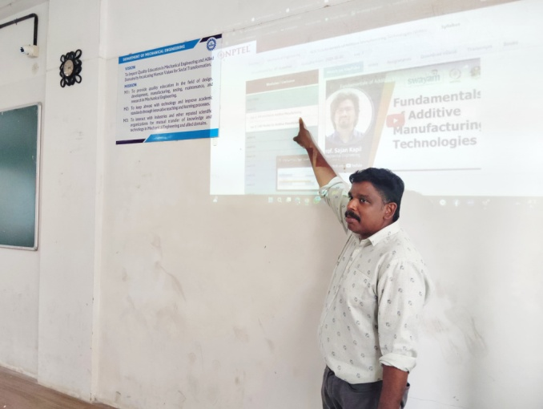

*ICT enabled class rooms –NPTEL Teaching*

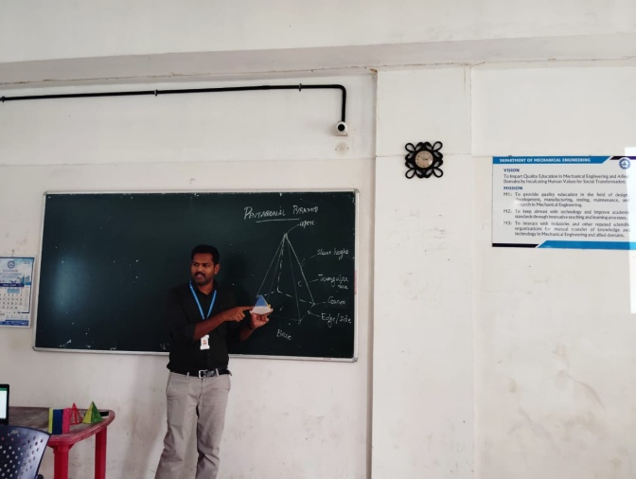

*ICT enabled class rooms –instructional solid models teaching*

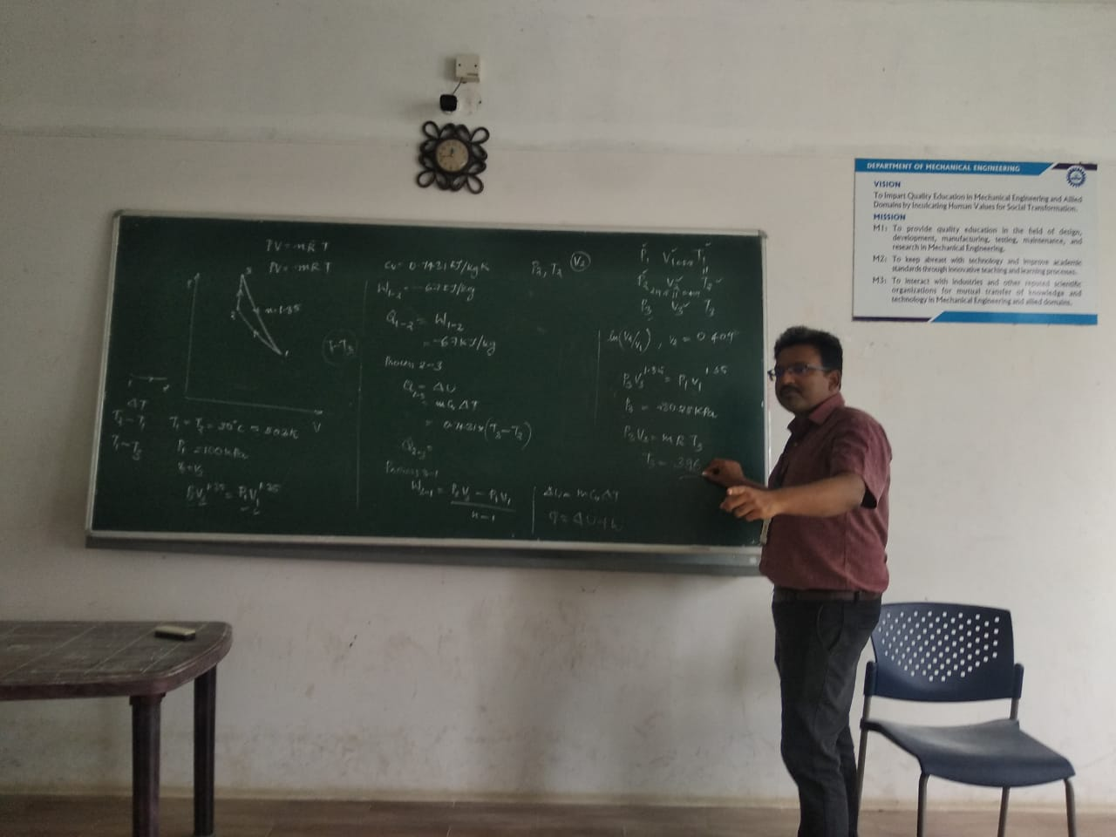

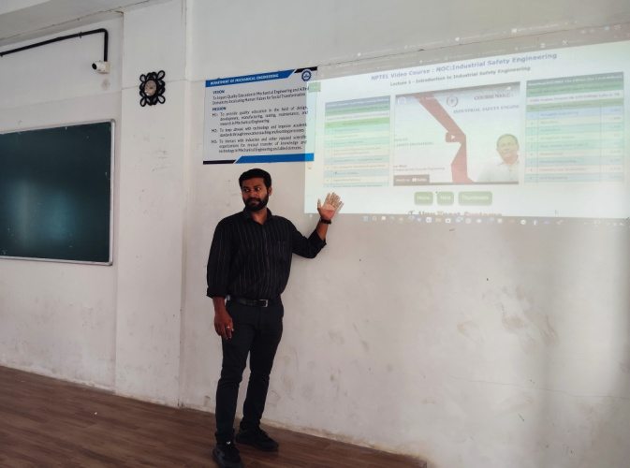

*Problem solving and power point presentation*

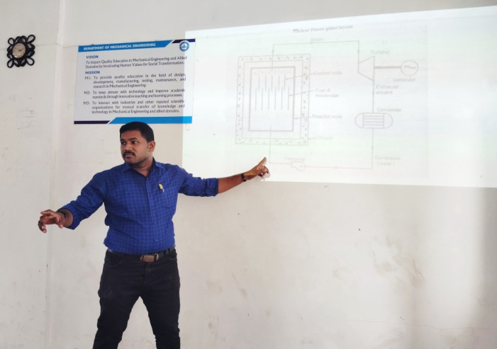

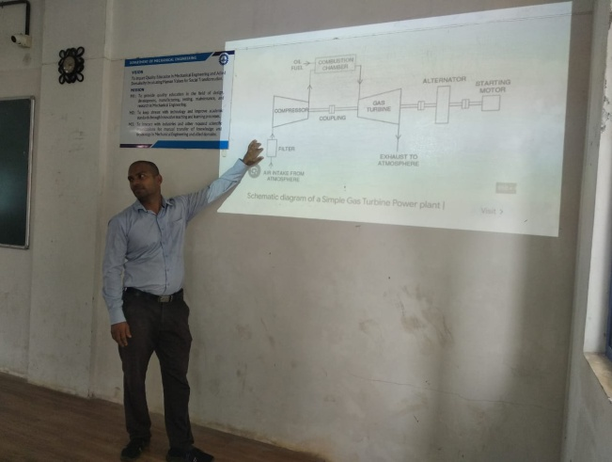

*Effective, efficient and engaging teaching and learning process*

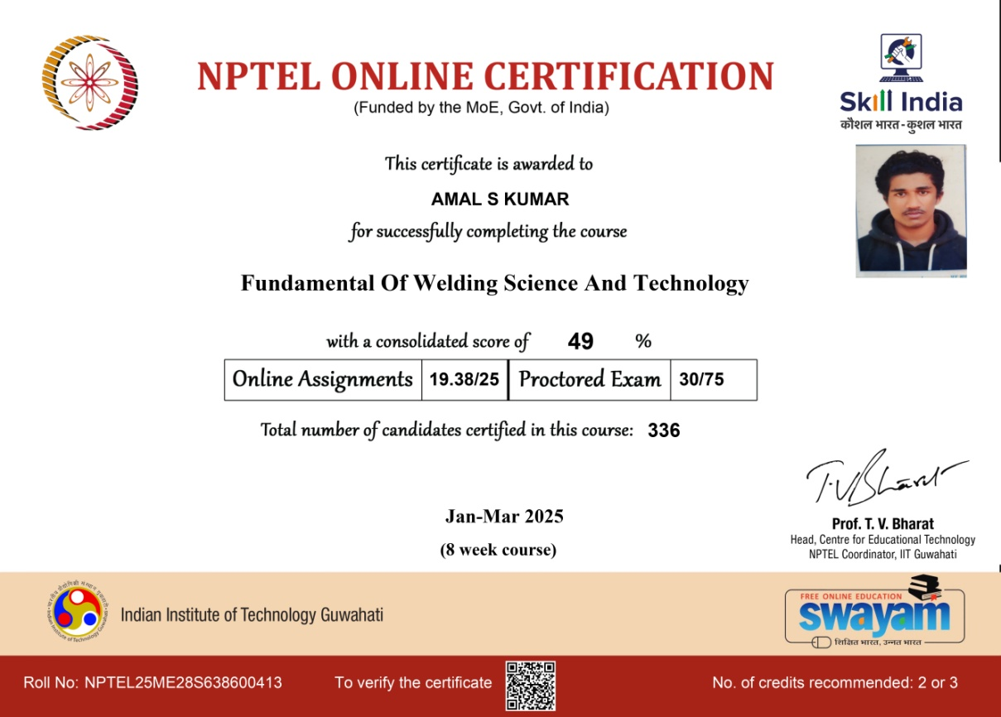

|  |  |  |  |
| --- | --- | --- | --- |
| Instructional Methods and Delivery Details | | | |
| S No | Method | Content delivery | Facility |
| 1 | Class Room Teaching | Power Point Presentations | ICT Enabled class room |
| Seminars |
| Group Discussions |
| Peer Learning |
| 2 | E-Learning | NPTEL Videos | Digital Library |
| Video / Animations | Internet |
| you tube videos | Google class room, Scheduled Meeting, |
|  | You-tube, Swayam, MOOCS |
| 3 | Assessment | Assignments | Off line |
| internal Assessments |
| 4 | Lab Demonstrations | Demonstration of Working models | Laboratory |
|
| 5 | Computer Assisted Learning | 2D & 3D Modeling | Software |
| Simulation& Analysis |
| 6 | Models | Using charts & Models | charts & Models |
| 7 | Project exhibitions | Project based learning | Laboratory |
| 8 | Seminar & Workshop based learning | Conducting workshops & seminars | ICT Enabled Seminar hall |

**Online Lecture and Assessment**

In an online lecture, the educator communicates course content (using a whiteboard, PowerPoint presentation, or similar tools) to students in a virtual setting instead of an auditorium. Online assessment is the process of evaluating students' learning progress and accomplishments using digital tools and technologies. Numerous formats are possible, including tests, assignments, surveys, and quizzes.

**Prepared 3D & Cut-Sectional Model**

The development of imagination is a crucial step in the learning process. 3D models and their demonstrations make it easier to understand and visualize objects, which help enhance thinking capacity and capability when drawing views of objects. In a class review, students suggested that interaction with such a method led to a better understanding of engineering drawing, particularly in orthographic projections and isometric views.

The objective of these activities is to expand technical understanding by actively engaging students in real world and personally meaningful projects. Project-Based Learning (PBL) starts with a problem and requires students to analyse and apply learned information and theories to solve it. Students work in groups to manage and complete assigned tasks. Teachers and industry experts provide guidance to execute projects. The Department of Mechanical Engineering conducts these activities regularly. Students further explore their work for their projects and are encouraged to participate.

**Hands-On Diagrams (Sketch) – Tutorial-Based Class**

This method involves hands-on practice sessions in which students draw sketches related to various engineering subjects, such as Engineering Graphics and Kinematics of Mechanisms. In these sessions, drawing neat sketches of velocity, acceleration, and cam profiles is essential for understanding the working principles of specific mechanisms and concepts. Faculty members from the Department of Mechanical Engineering regularly explain how to create schematic diagrams and illustrate their functionality.

**On-the-Job Teaching**

This innovative teaching method involves using actual tools, equipment, and materials to provide a better understanding and real-world experience. It aids in imparting lifelong learning to students. Faculty members use this approach to demonstrate assembly and operation, particularly in subjects such as Engineering Metrology and IC Engines.

Furthermore, students perform minor adjustments or routine maintenance on their own. To complete project designs and create models, they also utilize manufacturing and welding resources in practical applications.

**Hands-on training Workshops `**

The Department of Mechanical Engineering organizes workshops on DESIGN TO REALITY CAD + CAM to bridge the gap between industry and academia. The objective of such seminars and workshops is to provide hands-on exposure to students. These workshops emphasize these fields and help bridge the curriculum gap.

**Content beyond Syllabus**

The faculty members in the Department of Mechanical Engineering believe that going above and beyond the prescribed curriculum helps students learn more, increases their enthusiasm for the topic, and improves their knowledge of advanced modern tool usage for project work, analysis, and data interpretation These practices result in enhanced teaching and learning as well as improved attendance.

**Industry / Academia Expert Lectures /Alumni Lecture (Innovative tool for updating knowledge)**

The goal is to examine current technology, industry expectations, and progress through lectures and discussions with representatives from academia, industry, and alumni. The ability to connect theoretical knowledge with practical applications of technological advancements benefits students by expanding their understanding and incorporating valuable insights from real-world experience. Students receive information on the latest technological advancements, industry demands, and opportunities for higher education, among other relevant topics.

**NPTEL (National Programme on Technology Enhanced Learning)**

Technology-Enhanced Learning is a learning platform for higher education. The National Programme on Technology Enhanced Learning (NPTEL) is one of the major initiatives in this domain. By completing these courses, faculty members of the department acquire new knowledge and enhance their skills, which in turn improves their teaching effectiveness. Additionally, teachers encourage students to enroll in such programs to gain new knowledge and improve their learning abilities in their respective disciplines.

**Peer learning**

Peer learning is an educational practice in which students interact with their peers to achieve academic goals. Outstanding students mentor slow learners to enhance their understanding of the subject. Courses. are identified based on students' performance assessments, and difficult topics are discussed during extra class hours to reinforce learning.

**Google Classroom**

The use of Google Classroom integrates students into the digital learning revolution. It provides access to a question bank, study guides, and assignments at their convenience. The student(s) who are all absent, can independently access classroom resources from home, ensuring that they do not fall behind in their studies.

**Smart Class Room (Digital System)**

A smart classroom is a digital learning environment that enhances the teaching process by displaying instructional content on a screen rather than a blackboard.

This method improves lecture quality and creates an engaging classroom atmosphere. Smart classrooms aim to keep students actively involved in learning by incorporating virtual and audio-based teaching tools in addition to traditional textbooks.

**Assessment and Evaluation**

**Conventional Methods:**

* Continuous Internal Assessment (CIA) tests
* Class tests
* Tutorials
* Assignments

**Innovative Methods:**

Modern technical education emphasizes learning outcome-based assessment.

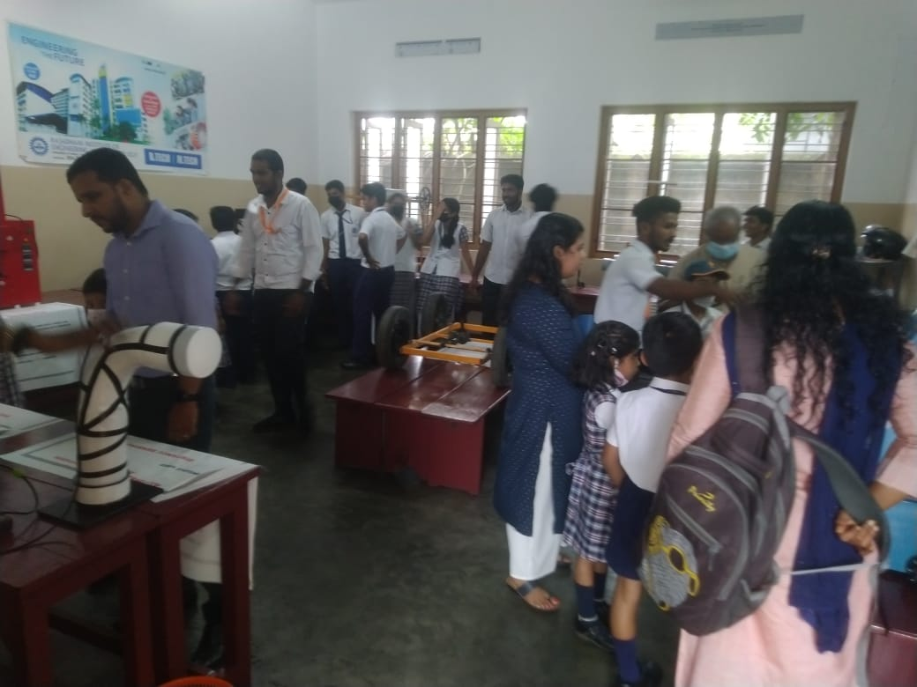

Mechanical engineering students of Rajadhani Institute of Engineering and Technology, demonstrated the working model projects in a technical project exhibition Sarvodaya Central Vidyalaya, Trivandrum on 14/11/2022.

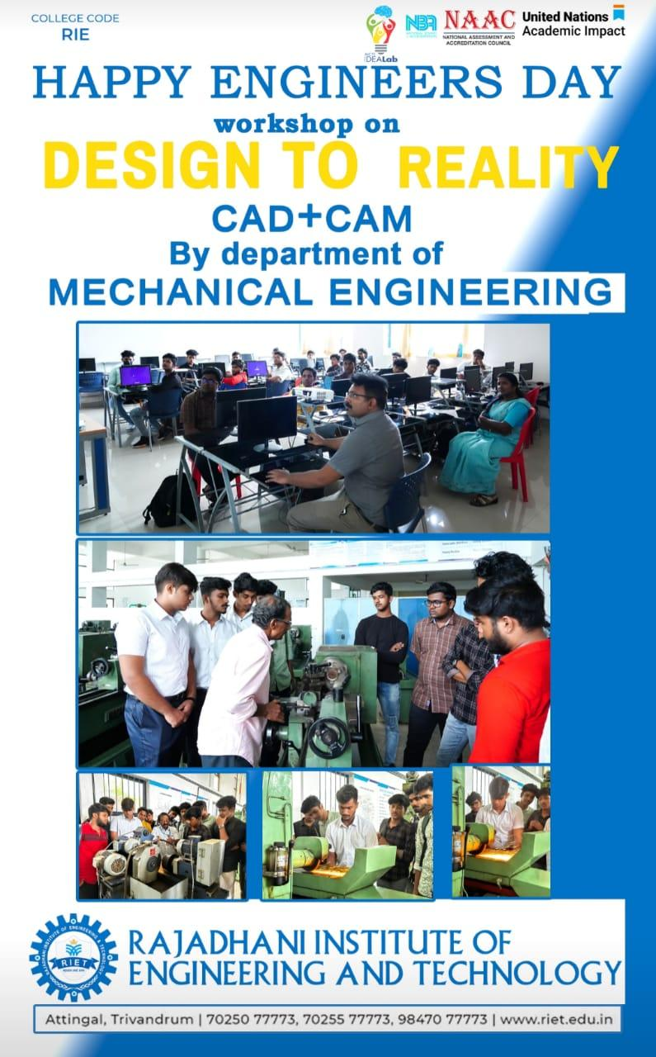

As part of Engineers day on 15 th September 2023, department of Mechanical engineering in association with ACME  one day workshop on Design to Reality.

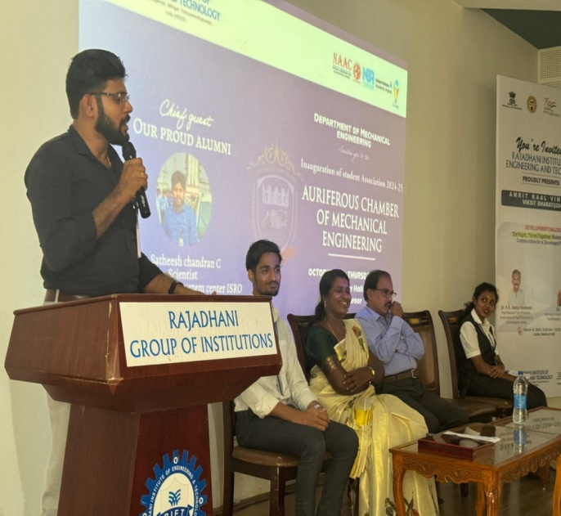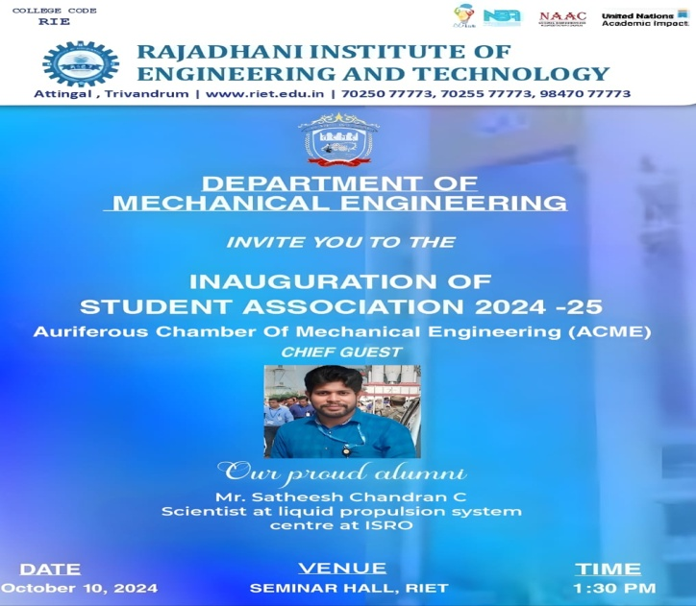

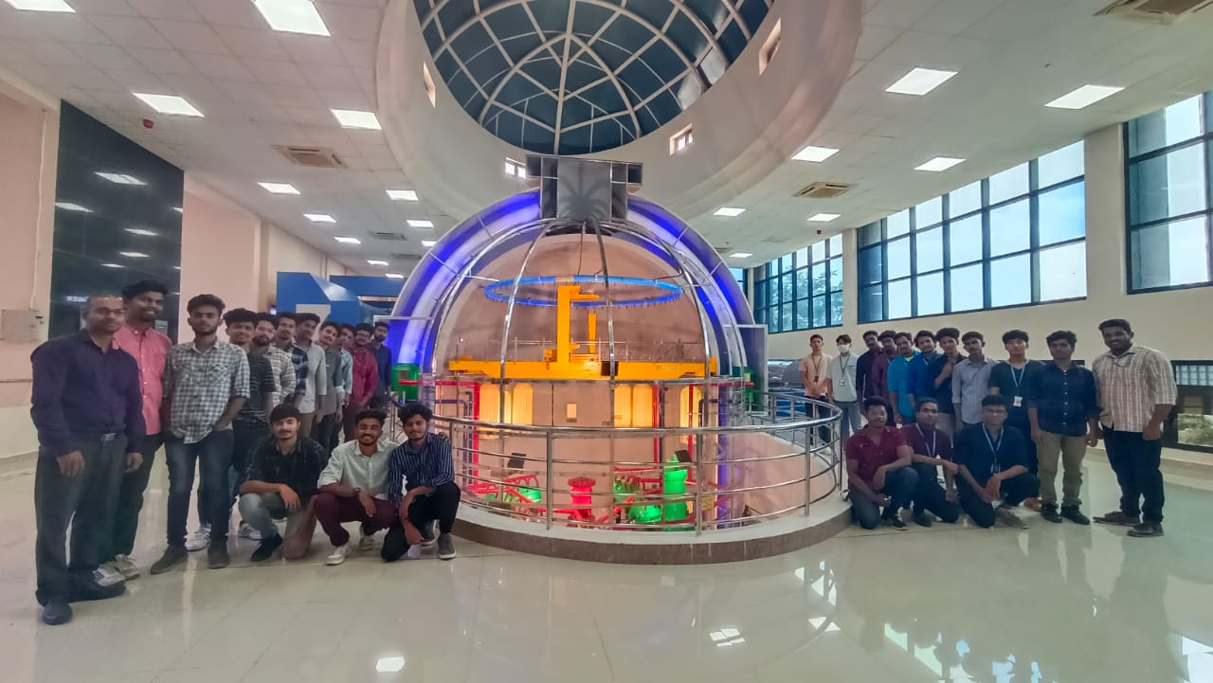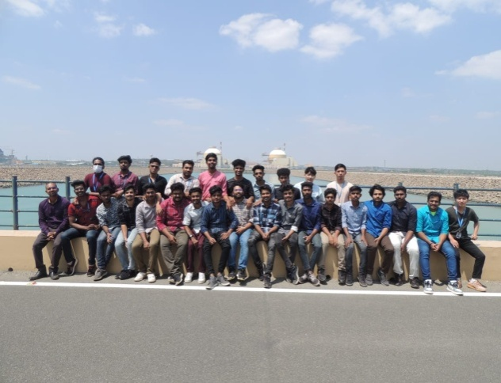

To bridge the gap in curriculum an one day industrial interaction at KUDANKULAM NUCLEAR POWER PLANT was arranged on 27th February 2023.

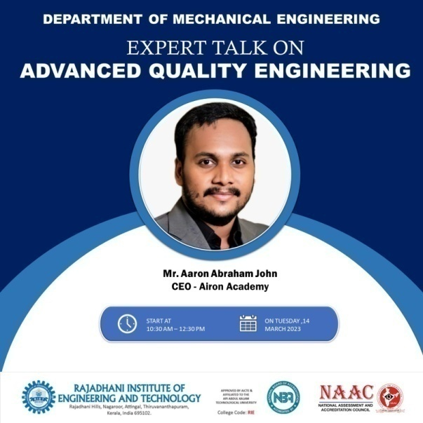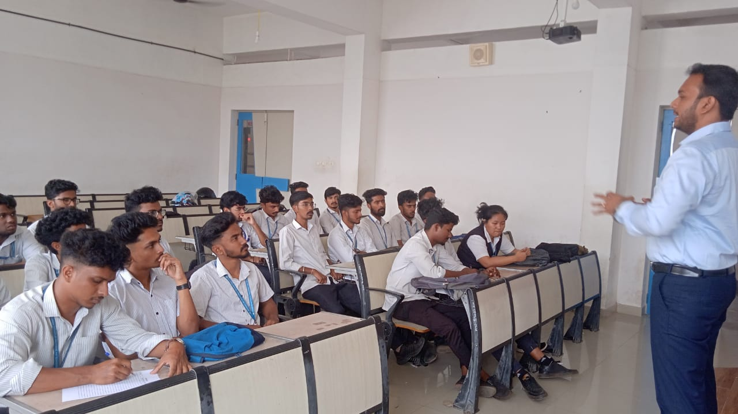

* Expert talk on advanced quality engineering -14/03/2023

#### 5.6 Faculty as participants in Faculty development/training activities/STTPs (15)

A Faculty scores maximum five points for participation

Participation in 2 to 5days Faculty development program: 3 Points

Participation > 5days Faculty development program: 5points

|  |  |  |  |
| --- | --- | --- | --- |
| Name of the Faculty | Max.5 per Faculty | | |
| CAYm1 2024-25 | CAYm2 2023-24 | CAYm3 2022-23 |
| Dr. Bindu S S | 5 | 5 | 5 |
| Mr. Sree Mahesh M P | 5 | 5 | 5 |
| Mr. Manoj A | 5 | 5 | 5 |
| Mr. Niju V S | 5 | 5 | 5 |
| Mr. Sree Raj M P | 5 | 5 | 5 |
| Mr. Joe Jeba Rajan | 5 | 5 | 5 |
| Mr. Krishnakumar K | 5 | 5 | 5 |
| Mr. Vijil J | 5 | 5 | 5 |
| Mr. Amal J Anil | 5 | 5 | 5 |
| Mr. Ullas S | 5 | 5 | 5 |
| Mr. Sourav R Vimal | 5 | 5 | 5 |
| Mr Krishnalal | 5 | 5 | 5 |
| Sum | 60 | 60 | 60 |
| RF=Number of Faculty required to comply with20:1Student-Faculty ratio as per 5.1 | 6 | 6 | 6 |
| Assessment= 3× (Sum/0.5RF)  (Marks limited to 15) |  |  |  |
| Average assessment over three years(Marks limited to15)= |  |  |  |

#### 5.7 Research and Development (30)

**5.7.1 Academic Research (10)**

Academic research includes research paper publications, Ph.D. guidance, and faculty receiving Ph.D. during the assessment period.

Number of quality publications in refereed/SCI Journals, citations, Books/Book Chapters etc. (6)

**5.7.1.1 List of faculty members with research paper publications**

|  |  |  |  |  |  |  |  |
| --- | --- | --- | --- | --- | --- | --- | --- |
| S. No. | Name of the Faculty | Title | Journal Name | Volume/Issue | Page | Year | ISSN/ESSN |
| 1 | Dr.Bindu S S | Design and fabrication of a low-cost reverse trike with hybrid drive mechanism | International Journal of Research and Analytical Reviews( IJRAR) | 12 | 708-713 | 2025 | 2349-5138 |
| 2 | Dr.Bindu S S | Enhanced mechanical and tribological performance of magnesium-boron carbibe composites fabricated via stir casting for light weight structural applications | Journal of Polymer and Composites | - | - | 2025 | 2321-2810 |
| 3 | Dr.Bindu S S | Experimental investigation of tig-welded aluminium 7075 joints: weld application & thermal properties | strad Research | 12 | 243-260 | 2025 | 0039-2049 |
| 4 | Dr.Bindu S S | Development of an iot-enabled fuel monitoring & alert system | International Journal of Research and Analytical Reviews( IJRAR) | 12 | 655-664 | 2025 | 2349-5138 |
| 5 | Manoj A | Innovation in semi-automated floor cleaning: design and prototype development | strad Research | 12 | 234-242 | 2025 | 0039-2049 |
| 6 | Manoj A | Development of an iot-enabled fuel monitoring & alert system | International Journal of Research and Analytical Reviews( IJRAR) | 12 | 655-664 | 2025 | 2349-5138 |
| 7 | Krishnakumar K | Experimental investigation of tig-welded aluminium 7075 joints: weld application & thermal properties | strad Research | 12 | 243-260 | 2025 | 0039-2049 |
| 8 | Krishnakumar K | Development of an iot-enabled fuel monitoring & alert system | International Journal of Research and Analytical Reviews( IJRAR) | 12 | 655-664 | 2025 | 2349-5138 |
| 9 | Krishnakumar K | Harnessing human power: a sustainable energy generation system using fitness equipment | International Journal of Research and Analytical Reviews( IJRAR) | 12 | 227-233 | 2025 | 2349-5138 |
| 10 | Sree Mahesh M P | Design and fabrication of a low-cost reverse trike with hybrid drive mechanism | International Journal of Research and Analytical Reviews( IJRAR) | 12 | 708-713 | 2025 | 2349-5138 |
| 11 | Sree Mahesh M P | Innovation in semi-automated floor cleaning: design and prototype development | strad Research | 12 | 234-242 | 2025 | 0039-2049 |
| 12 | Sree Mahesh M P | Harnessing human power: a sustainable energy generation system using fitness equipment | International Journal of Research and Analytical Reviews( IJRAR) | 12 | 227-233 | 2025 | 2349-5138 |
| 13 | Sourav R Vimal | Design and fabrication of a low-cost reverse trike with hybrid drive mechanism | International Journal of Research and Analytical Reviews( IJRAR) | 12 | 708-713 | 2025 | 2349-5138 |
| 14 | Sourav R Vimal | Experimental investigation of tig-welded aluminium 7075 joints: weld application & thermal properties | strad Research | 12 | 243-260 | 2025 | 0039-2049 |
| 15 | Sourav R Vimal | Experimental investigation of tig-welded aluminium 7075 joints: weld application & thermal properties | strad Research | 12 | 243-260 | 2025 | 0039-2049 |
| 16 | Sourav R Vimal | Design and integration of a semi autonomous robot for agricultural mechanization | International Journal of Research and Analytical Reviews( IJRAR) |  |  | 2025 | 2349-5138 |
| 17 | Vijil J | Design and fabrication of a low-cost reverse trike with hybrid drive mechanism | International Journal of Research and Analytical Reviews( IJRAR) | 12 | 708-713 | 2025 | 2349-5138 |
| 18 | Vijil J | Experimental investigation of tig-welded aluminium 7075 joints: weld application & thermal properties | strad Research | 12 | 243-260 | 2025 | 0039-2049 |
| 19 | Vijil J | Design and integration of a semi autonomous robot for agricultural mechanization | International Journal of Research and Analytical Reviews( IJRAR) |  |  | 2025 | 2349-5138 |
| 20 | Ullas S | Development of an iot-enabled fuel monitoring & alert system | International Journal of Research and Analytical Reviews( IJRAR) | 12 | 655-664 | 2025 | 2349-5138 |
| 21 | Ullas S | Design and integration of a semi autonomous robot for agricultural mechanization | International Journal of Research and Analytical Reviews( IJRAR) |  |  | 2025 | 2349-5138 |
| 22 | Amal J Anil | Innovation in semi-automated floor cleaning: design and prototype development | strad Research | 12 | 234-242 | 2025 | 0039-2049 |
| 23 | Amal J Anil | Design optimization and implementation of a maglev wind turbine prototype | High Technology Letters | 31 | 373-382 | 2025 | 1006-6748 |
| 24 | Joe Jeba Rajan K | Design optimization and implementation of a maglev wind turbine prototype | High Technology Letters | 31 | 373-382 | 2025 | 1006-6748 |
| 25 | Joe Jeba Rajan K | Harnessing human power: a sustainable energy generation system using fitness equipment | International Journal of Research and Analytical Reviews( IJRAR) | 12 | 227-233 | 2025 | 2349-5138 |
| 26 | Sreeraj M P | Design optimization and implementation of a maglev wind turbine prototype | High Technology Letters | 31 | 373-382 | 2025 | 1006-6748 |
| 27 | Sreeraj M P | Harnessing human power: a sustainable energy generation system using fitness equipment | International Journal of Research and Analytical Reviews( IJRAR) | 12 | 227-233 | 2025 | 2349-5138 |
| 28 | Niju V S | design optimization and implementation of a maglev wind turbine prototype | High Technology Letters | 31 | 373-382 | 2025 | 1006-6748 |
| 29 | Niju V S | design and integration of a semi autonomous robot for agricultural mechanization | International Journal of Research and Analytical Reviews( IJRAR) |  |  | 2025 | 2349-5138 |

**5.7.1.2 List of faculty members with Citation**

|  |  |  |  |
| --- | --- | --- | --- |
| S. No | Name of the Faculty | Citation | Citation screenshot |
| 1 | Dr. Bindu S S | 7 | WhatsApp Image 2025-05-10 at 8 |

**5.7.1.2 Details of patent filed and granted**

|  |  |  |  |  |
| --- | --- | --- | --- | --- |
| S. No | Inventor name | Title of the invention | patent number | Patent status |
| 1 | Mr Joe Jeba RAJAN | MODULAR COCONUT SCRAPPER | 136011 | Success |

#### WhatsApp Image 2025-05-07 at 11

#### 5.7.1.4 Number of books published

|  |  |  |  |
| --- | --- | --- | --- |
| S. No. | Name of the Faculty | Title of book | ISSN/ESSN |
| 1 | Dr.Bindu S S | Computational study in two phase flow of liquid nitrogen with different internal coatings CRC press Taylor and Francis group, London | ISBN 978-0-8153-5760-5 |

**5.7.1.5 Ph.D. guidance, and faculty receiving Ph.D. during the assessment period.**

**Mr Krishna Kumar K,** Assistant Professor of the department pursuing Ph.D. in KTU Abdhul Kalam Technological University

**Mr Joe Jeba Rajan** Assistant Professor of the department pursuing Ph.D. in Noorul Islam College, Thucklay, Kanyakumari district

**5.7.1.6 Professional Society Membership**

|  |  |  |  |
| --- | --- | --- | --- |
| *Sl No* | *Name of the Faculty Member* | *Name of the Professional Society* | *Membership No* |
| *1* | *Ms.Bindu S S* | *Indian Cryogenic Council* | *LM-814* |
| *2* | *Mr. Sreemahesh M P* | *ISTE* | *LM112821* |
| *3* | *Mr. Manoj A* | *ISTE* | *LM112818* |
| *4* | *Mr.Niju V S* | *ISTE* | *LM112820* |
| *5* | *Mr. Sree raj M P* | *ISTE* | *LM112819* |
| *6* | *Mr. Joe Jeba Rajan* | *ISTE* | *LM112822* |
| *7* | *Mr.Asok.R* | *ISTE* | *LM112816* |

#### 5.7.2 Sponsored Research (5)

* Funded research:

NIL

|  |  |  |  |
| --- | --- | --- | --- |
| **CAYm1** | | | |
| **SN** | **Project title** | **Funding agency**  **name** | **Amount** |
| 1 |  |  |  |
| 2 |  |  |  |
| .. |  |  |  |
| **CAYm2** | | | |
| 1 |  |  |  |
| 2 |  |  |  |
| .. |  |  |  |
| **CAYm3** | | | |
| 1 |  |  |  |
| 2 |  |  |  |
| .. |  |  |  |
| **Totalamountforpast3years** | | |  |

#### 5.7.3 Development activities(10)

5.7.3.1 Product Development

|  |  |  |  |  |
| --- | --- | --- | --- | --- |
| S. No. | Students | Name of The Product | Faculty | Remarks |
| 1 | Deepak Krishna U Jerin Jose Gopi Krishna V S Vivek S M | Design and fabrication of semi automatic floor cleaning machine | Mr Manoj A | floor cleaning methods by integrating vacuuming, spraying, and mopping |
| 2 | Bosco lalenkawla Jeevan P R Akhila G S | Maglev Wind Turbine |  |  |
| 3 | Sidharth S Nair Sankar M S Abhiram P Adersh P B | Design & Fabication of Reersed hybrid Trike |  |  |
| 4 | Akshay M S Athul Murali Vignesh Sajeev Soorya narayanan | Multi Tool Concurrent Drilling Machine |  |  |
| 5 | Ambady A Ashwin S S Harikrishnan M Skandhan S S | Design and Fabrication of Sorting Conveyor |  |  |
| 6 | Navaneeth S S Karthik Hari Ajan J Deep Mohammed Thariq N | Voice controlled Wheel cair for disabled person |  |  |
| 7 | Ans S Navas Arjun Prasad Ramakrishnan M P Vishnu Viswanath Bimin J Babu | Fabrication of Atmospheric Watergenerator using Hyrogel |  |  |

5.7.3.2 Research laboratories

|  |  |  |  |  |
| --- | --- | --- | --- | --- |
| B RESEARCH LABORATORIES | | | | |
| EQUIPMENT DETAILS OF RESEARCH CENTRE | | | | |
| S. No. | Equipment Name | Purpose | Date of Purchase | Cost |
| 1 | Universal Testing Machine 1000 K N capacity |  | 12/17/2009 | 1,037,204 |
| 2 | UNIVERSAL MILLING MACHINE |  | 28.05.2012 | 642290 |
| 3 | CNC TRAINER LATHE MACHINE |  | 09.02.2012 | 769650 |
| 4 | CNC TRAINER MILLING MACHINE |  | 09.02.2012 | 640840 |
| 5 | PROFILE PROJECTOR |  | 24.09.2012 | 109120 |
| 6 | AUTOCOLLIMATOR |  | 24.09.2012 | 140800 |
| 7 | *CNC TRAINER LATHE MACHINE* |  | *09.02.2012* | *769650* |
| 8 | *CNC TRAINER MILLING MACHINE* |  | *09.02.2012* | *640840* |
| 9 | UNMANNED AERIAL VEHICLE LAB |  |  |  |
| 10 | WIND TUNNEL FACILITY |  |  |  |
| 11 | BENSON BOILER |  |  |  |
| 12 | 3D PRINTING |  |  |  |
| 13 | LASER CUTTING |  |  |  |
| 14 | 3D SCANNER |  |  |  |
| 15 | CNC WOOD ENRATE MACHINE |  |  |  |
| 16 | FOOD PRINTER |  |  |  |
| 17 | DRONE TECH |  |  |  |
| 18 | PCB PROTOTYPING MACHINE |  |  |  |

**5.7.3.3 Instructional materials**

Based on the subject, different instructional materials are prepared by the faculty. The instructional materials are:

* Animation Video Clippings
* Power point Presentation Slides
* Hand Written Notes
* Journal Papers and Relevant Website Details
* Printed Copy of Materials
* Laboratory Manual (Hard Copy or Soft Copy)

Title of NPTEL Video in central library

Lab manual table required

5.7.3.4 Animated videos for course delivery

|  |  |  |
| --- | --- | --- |
| S. No | Course name | URL animated images |
| 1 | Management for Engineers | <https://youtu.be/6cJBwQOFc9M?si=hDNnnN7bGqr1wg4C> |
| 2 | Engineering Graphics | <https://www.youtube.com/watch?v=zKX1juGsYBI> |
| 3 | Sustainable Engineering | <https://youtu.be/d1JcmGAWq68?si=T5pETtZSBm6U1j7M> |
| 4 | Dynamics of Machinery | <https://www.youtube.com/watch?v=tjsEKAHzUL0> |
| 5 | Programming in C | <https://youtu.be/LXsTKLqJpAw?si=CFA3nxFpPmhub3sP> |
| 6 | Industrial Engineering | <https://youtu.be/ECfiQNnwNoY?si=vFlFvCP4FrMG1SQ7> |

**5.7.4 Working models/charts/monograms etc.**

The Department has many charts created by students which are displayed in Research Laboratory. This prototype models helps the students to understand the working of charts in a better manner. Also, this can be used for better teaching and Learning Process.

5.7.4.1 List of charts in laboratory

|  |  |  |
| --- | --- | --- |
| S. No. | Name of laboratory | List of chart |
| 1 | Thermal Engineering Laboratory | Four stroke petrol engine |
| Two stroke petrol engine |
| Diesel power plant Layout |
| Valve actuating mechanism |
| Differential |
| Basic parts of an IC engin |
| 2 | Machine tools lab | Centre lathe |
| Lathe work holding devices and accessories |
| Lathe operations |
| Shaping machine and its parts |
| Paining machine |
| Radial Drilling machine |
| Surface grinder |
| tool and cutter grinder |
| slotting machine |
| Milling machine |
| Cylindrical grinder |
| Drilling machine operations |
| 3 | Mechanical engineering lab | Mechanical Comparator |
| Profile projection |
| Tool maker’s microscope |
| Floating carriage micrometer |
| Vernier Height Gauge |
| 4 | Mechanical Engineering Workshop | Carpentry cutting and boring tools |
| Foundry tools |
| Carpentry |
| Blacksmith tools |
| Fitting tools |
| Welding Equipment |
| Gas flames |
| Welding process |
| Gas welding equipment’s |
| 5 | Fluid Mechanics lab | Kaplan turbine |
| Reciprocating pump |
| Display board for pipe, pipe fitting and valve |
| Differential impellers of pump and turbines |

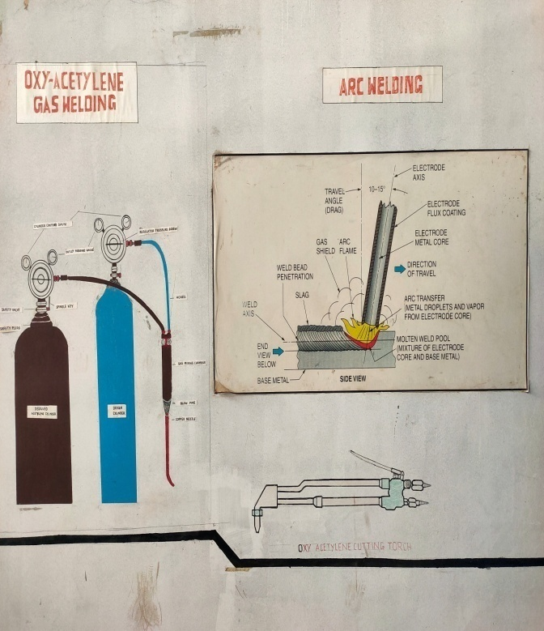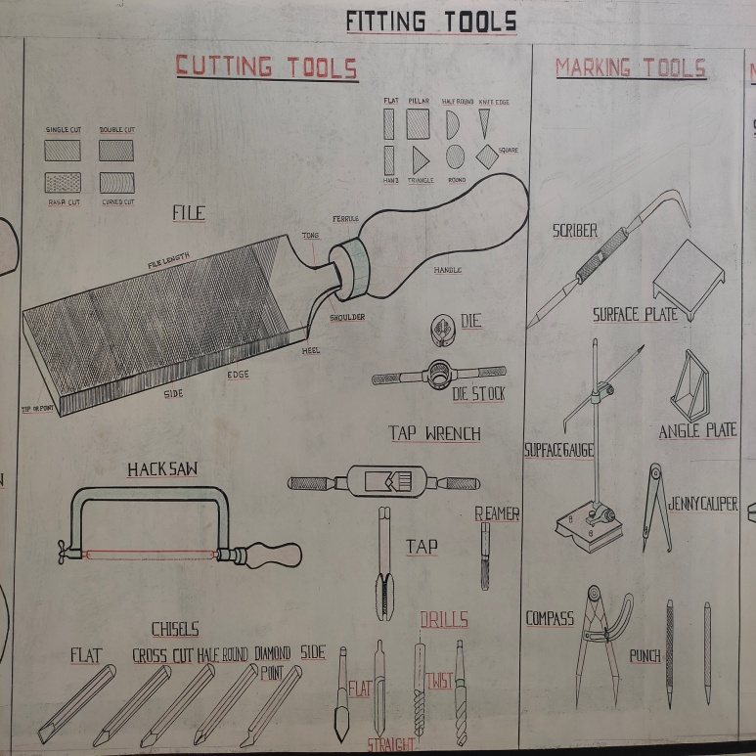

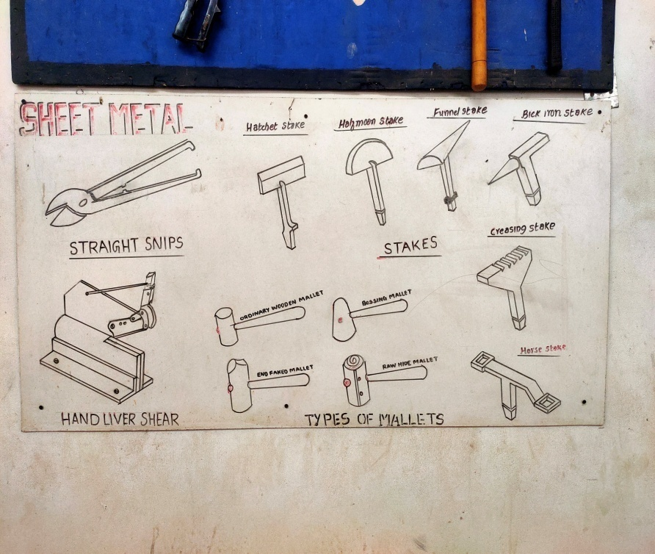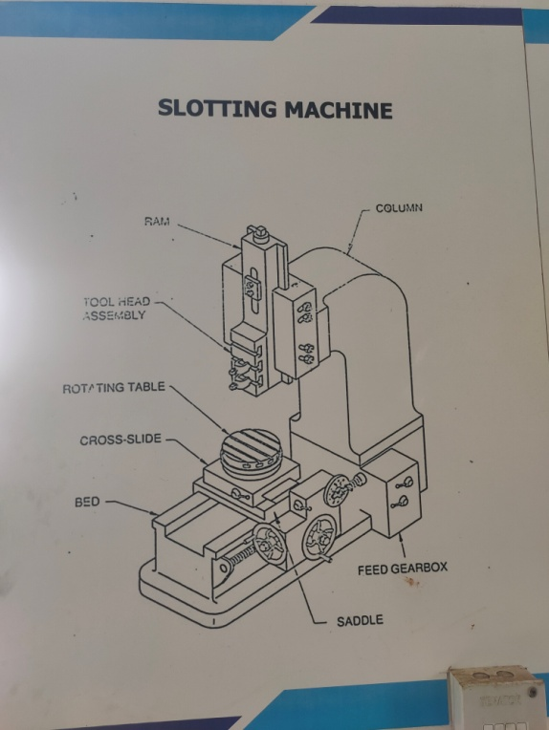

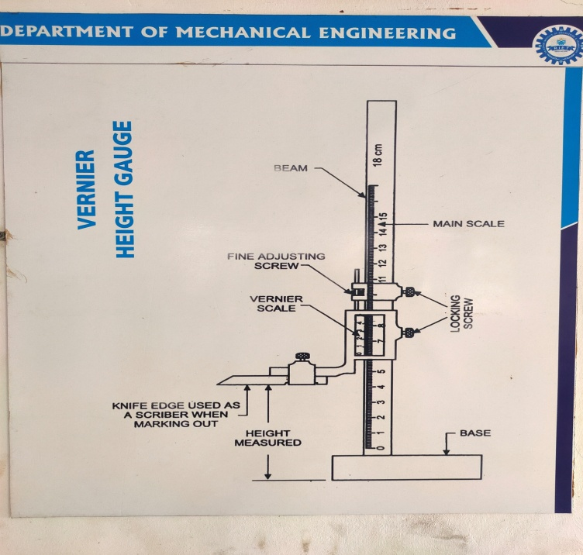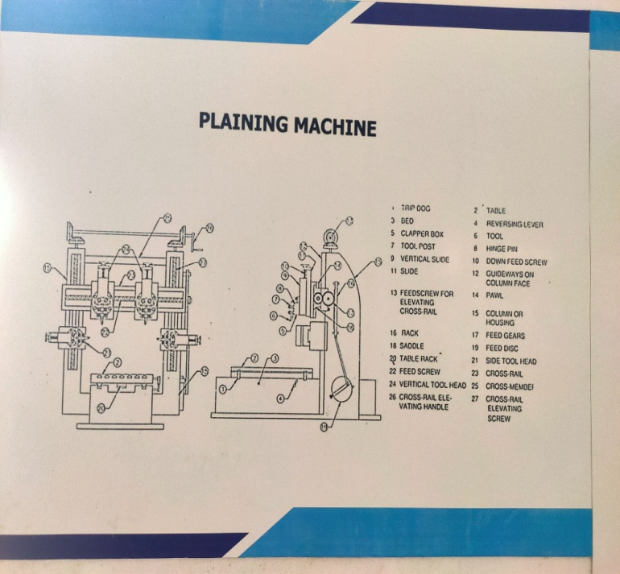

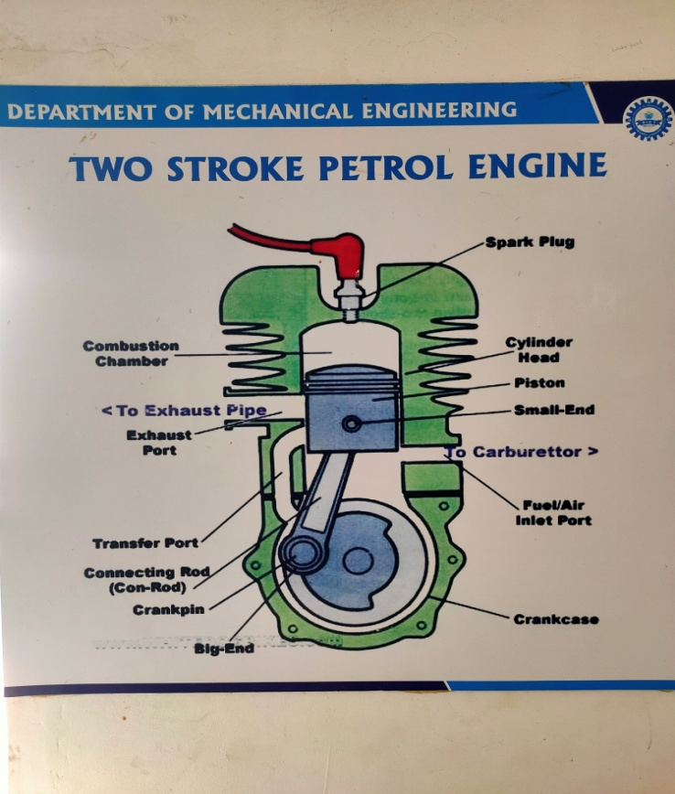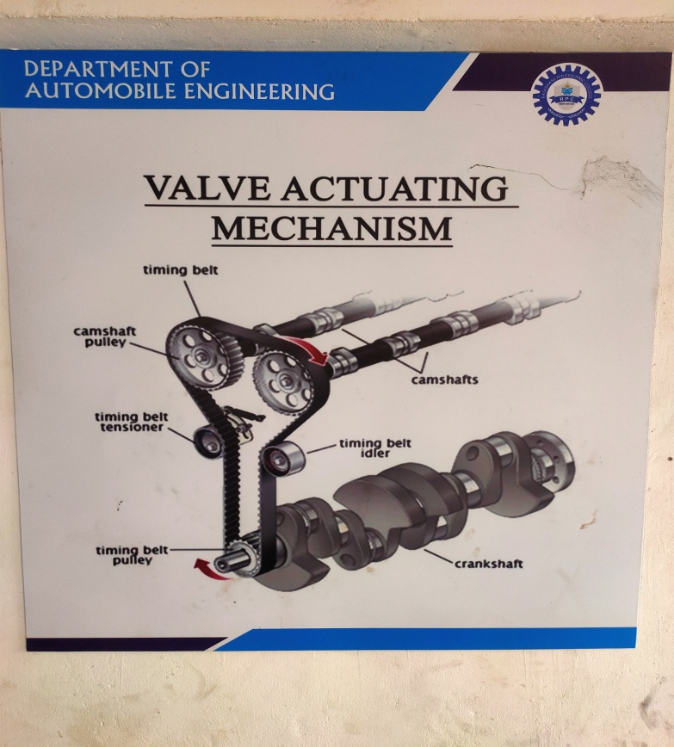

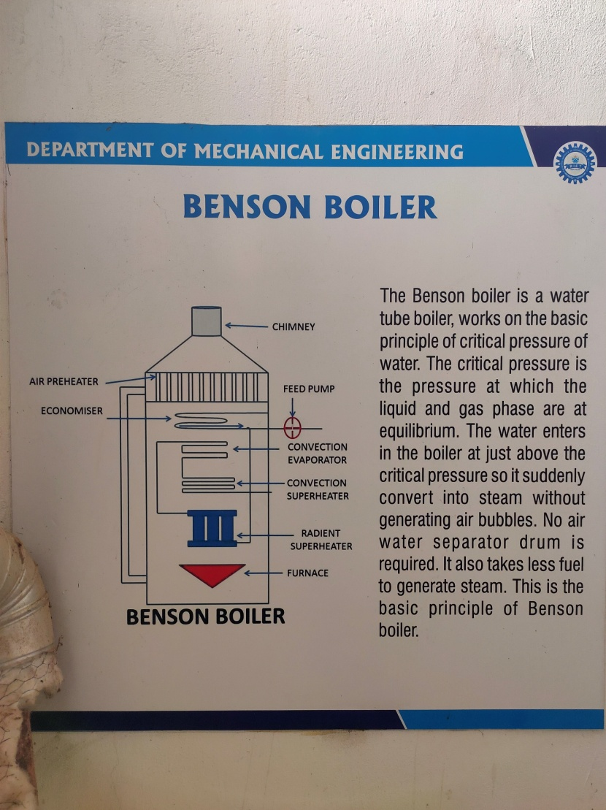

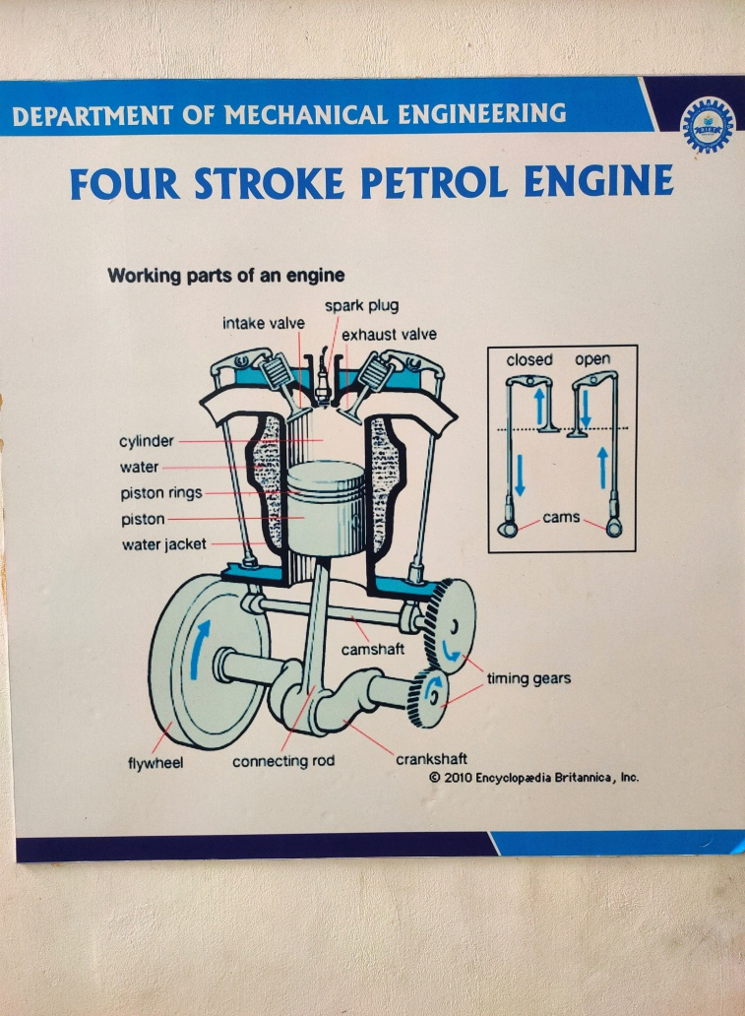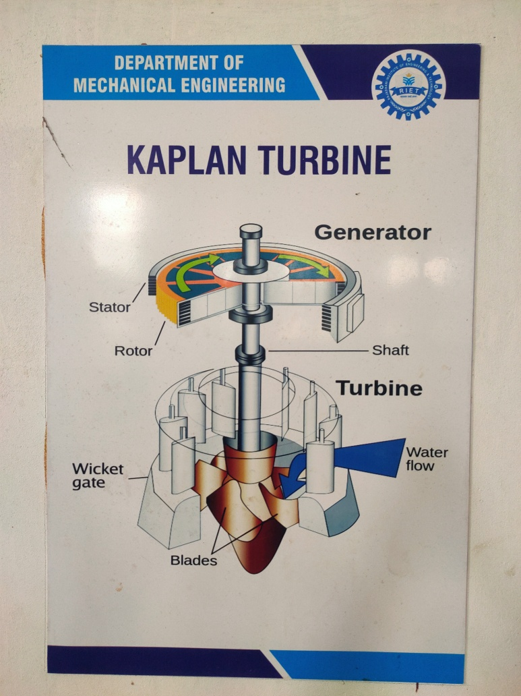

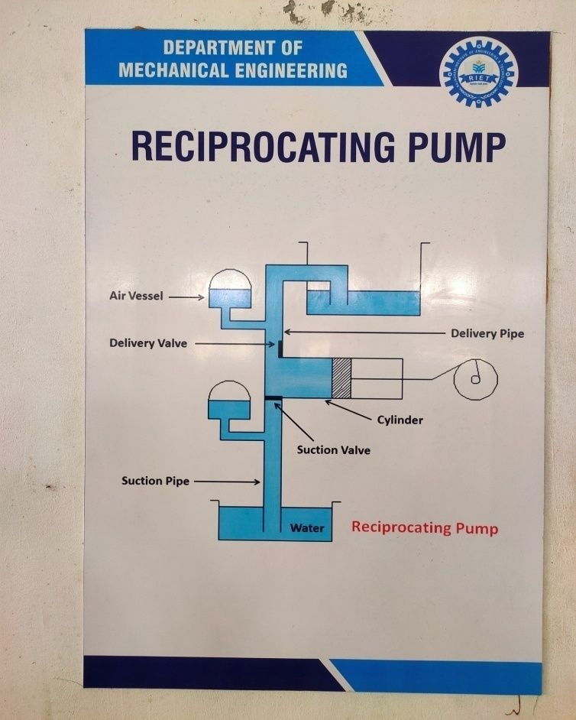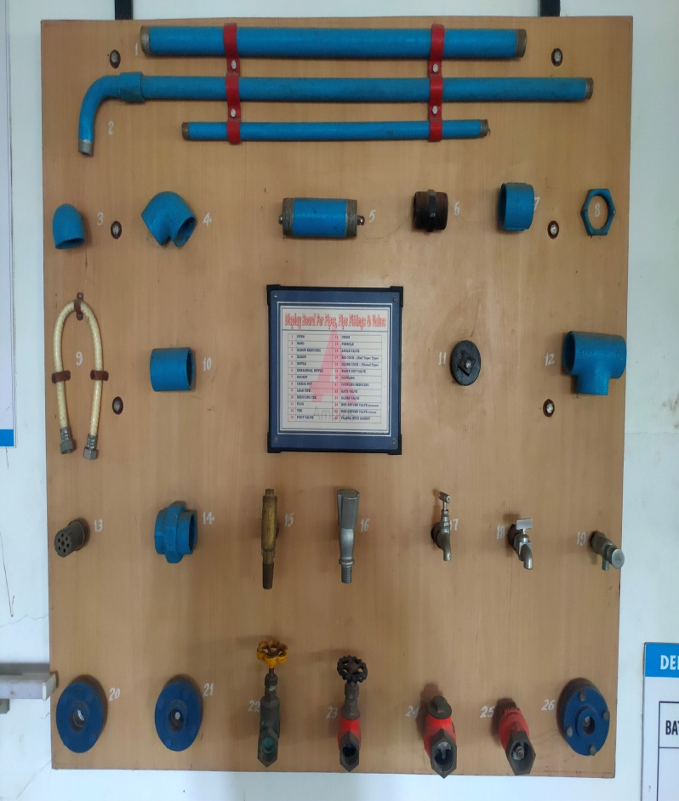

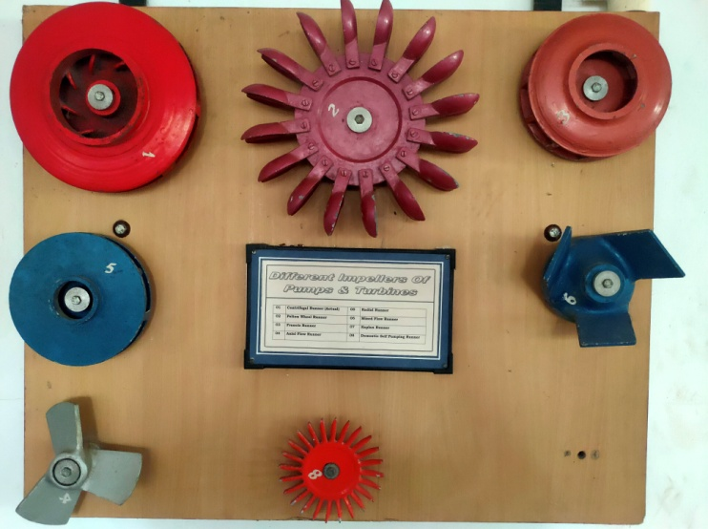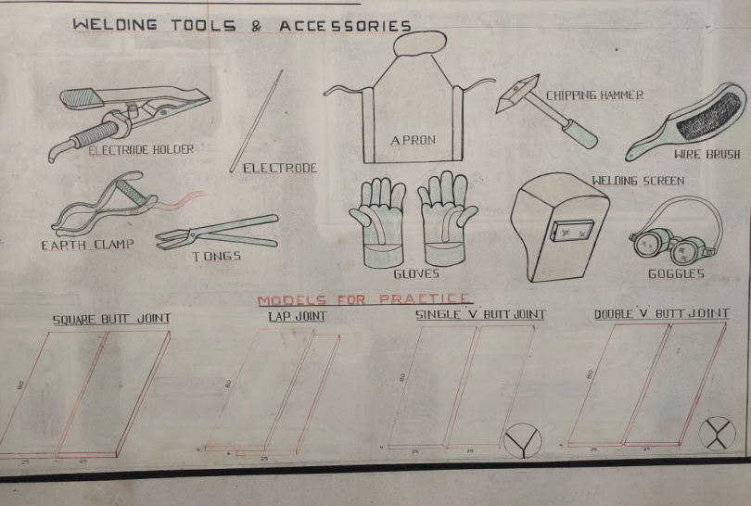

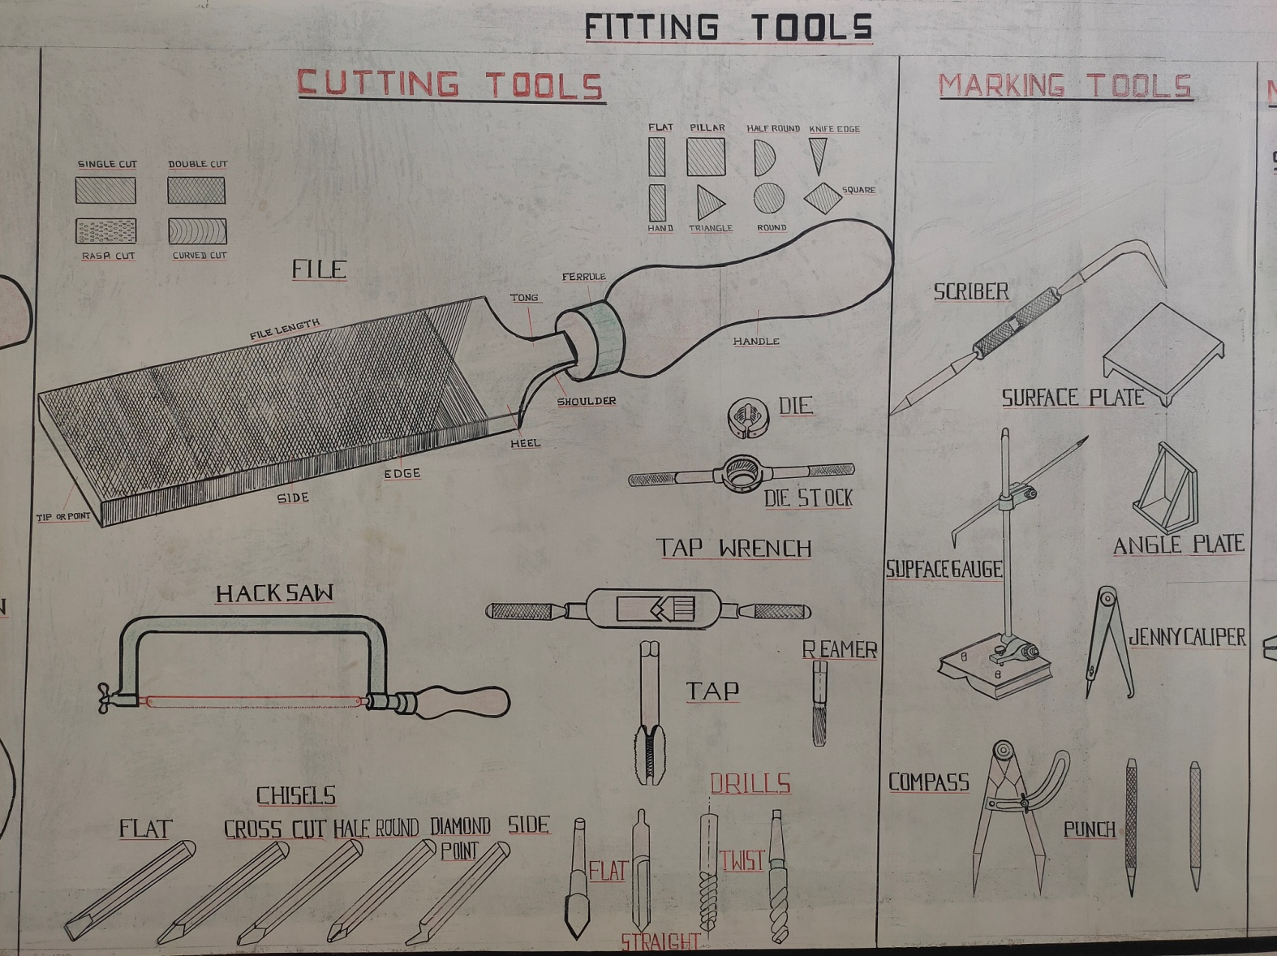

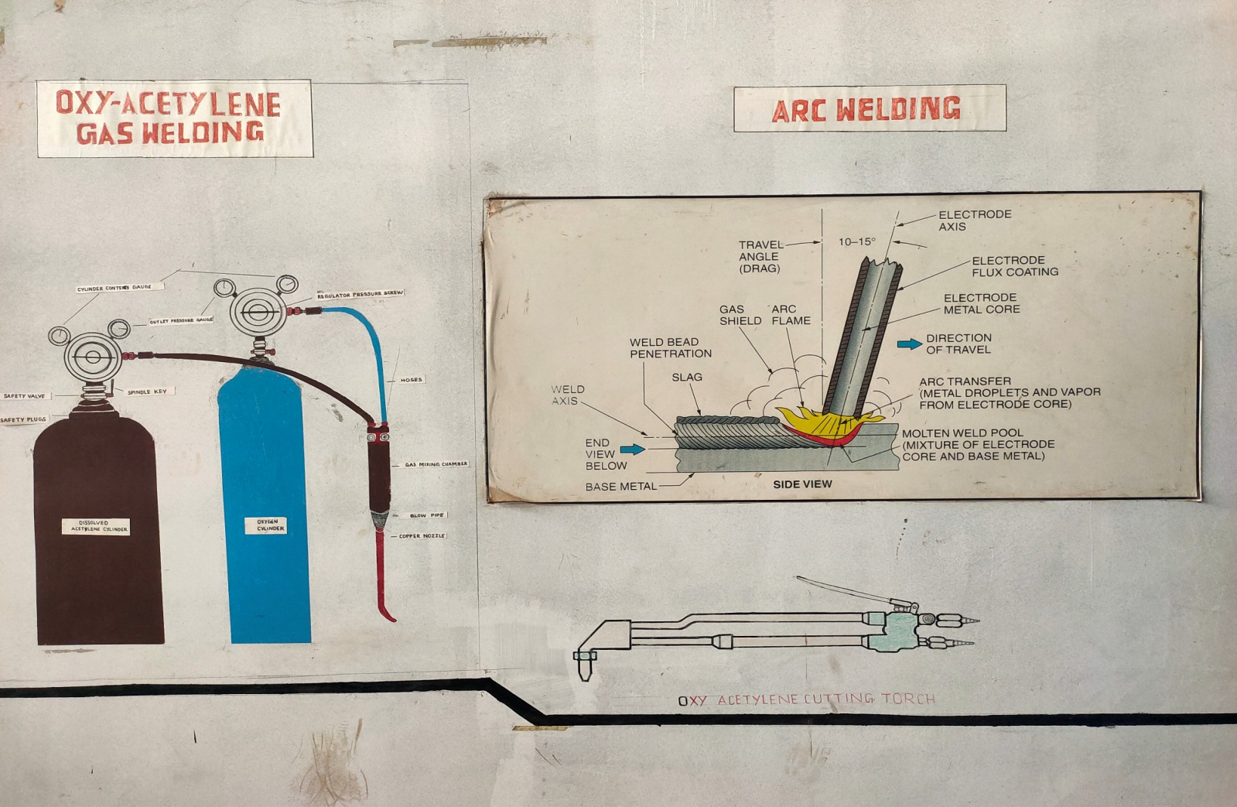

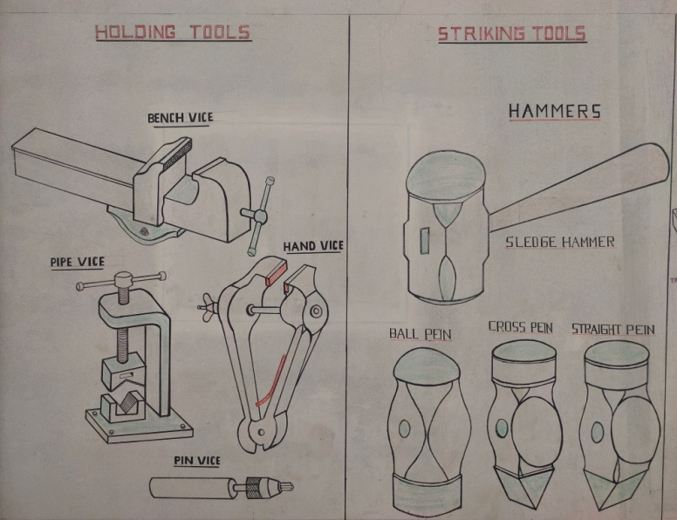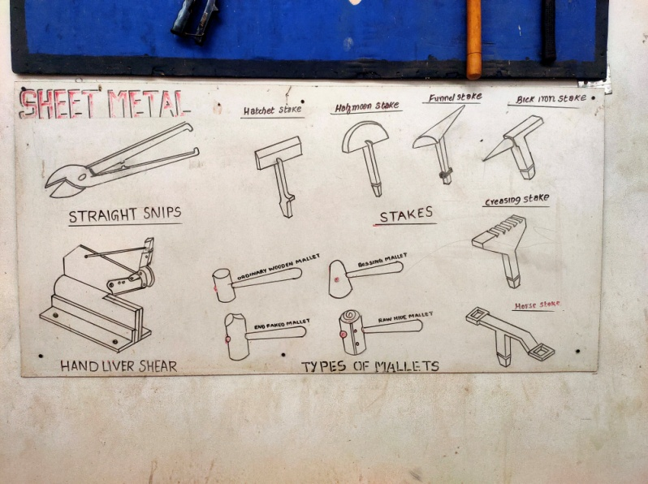

#### Consultancy (from Industry) (5)

|  |  |  |  |
| --- | --- | --- | --- |
| **CAYm1** | | | |
| **SN** | **Project title** | **Funding agency**  **name** | **Amount** |
| 1 |  |  |  |
| 2 |  |  |  |
| .. |  |  |  |
| **CAYm2** | | | |
| 1 |  |  |  |

|  |  |  |  |
| --- | --- | --- | --- |
| 2 |  |  |  |
| .. |  |  |  |
| **CAYm3** | | | |
| 1 |  |  |  |
| 2 |  |  |  |
| .. |  |  |  |
| **Totalamountforpast3years** | | |  |

#### 5.8 Faculty Performance Appraisal and Development System (FPADS) (30)

|  |  |  |  |  |
| --- | --- | --- | --- | --- |
| **Details of implementation and effectiveness of self-appraisal system - 2024-25** | | | | |
| S No. | Name of the Faculty | Rating | Suggestions | Effectiveness |
| 1 | Dr. Bindu S S |  |  |  |
| 2 | Mr. Sree Mahesh M P |  |  |  |
| 3 | Mr. Manoj A |  |  |  |
| 4 | Mr. Niju V S |  |  |  |
| 5 | Mr. Sree Raj M P |  |  |  |
| 6 | Mr. Joe Jeba Rajan |  |  |  |
| 7 | Mr. Krishnakumar K | Very Good | Advised to Complete the course work and propose the confirmation | Confirmation Completed |
| 8 | Mr. Vijil J |  |  |  |
| 9 | Mr. Amal J Anil |  |  |  |
| 10 | Mr. Ullas S |  |  |  |
| 11 | Mr. Sourav R Vimal |  |  |  |
| 12 | Mr Krishnalal |  |  |  |

The assessment is based on:

* Awell-definedsystemforfacultyappraisalforalltheassessmentyears(10)
* Its implementation and effectiveness(20)

#### 5.9 Visiting/Adjunct/Emeritus Faculty etc. (10)

AdjunctfacultyalsoincludesIndustryexperts.Providedetailsofparticipationandcontributionsin teaching and learning and /or research by visiting/adjunct/Emeritus faculty etc. for all the assessment years:

* Provision of inviting/having visiting/adjunct/emeritus faculty(1)
* Minimum 50 hours per year interaction with adjunct faculty from industry/retired professors etc.

(Minimum50hoursinteractioninayearwillresultin3marksforthatyear; 3marks x3 years = 9 marks